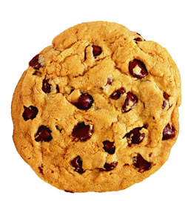
Calling all Bakers!!
Who likes baking cookies? You do!
The youth are asking for assistance from the cookie bakers among us to help us keep the “Cookie Walk” an ongoing, memorable and effective fund raising tradition. We are so excited to continue in partnering with the Market Place of Miracles and offering this one stop Christmas shop available to our community!
Please supply us with 4 batches of cookies (8-10 dozen) of the same variety, or more, of homemade cookies.
Have a family favorite? Great we’ll take it. Want to try out a new recipe? That will do too.
Fill in the bottom slip with your name and your top two cookie options you would be willing to make.
Because we want to have a large variety of types of cookies we will notify you of your cookie option that has been chosen upon reviewing your slip. Slips should be returned no later than November 19th.
Any questions please contact the youth department at uthrock@fumchurch.com
Cookie walk benefits youth mission trips.
(All youth are requested to help in this fundraiser because of the ongoing nature of fundraising that benefits both current and future trips.
Please help us in this endeavor and take a slip and make some cookies.)
2017 Cookie Walk Cookie Baker Sign Up:
Baker’s Name:_________________________________________________________________
Email: _____________________________________________________
Best Contact Number: ________________________________________
Cookie Option #1 ______________________________________________________________________________
Cookie Option #2 ______________________________________________________________________________
Yes, I would like to provide 4 batches (8-10) dozen of each option listed above.
Please return this form to Lynn Rapp or place in the Cookie Jar
(in Main Lobby) no later than November 19th, 2017

