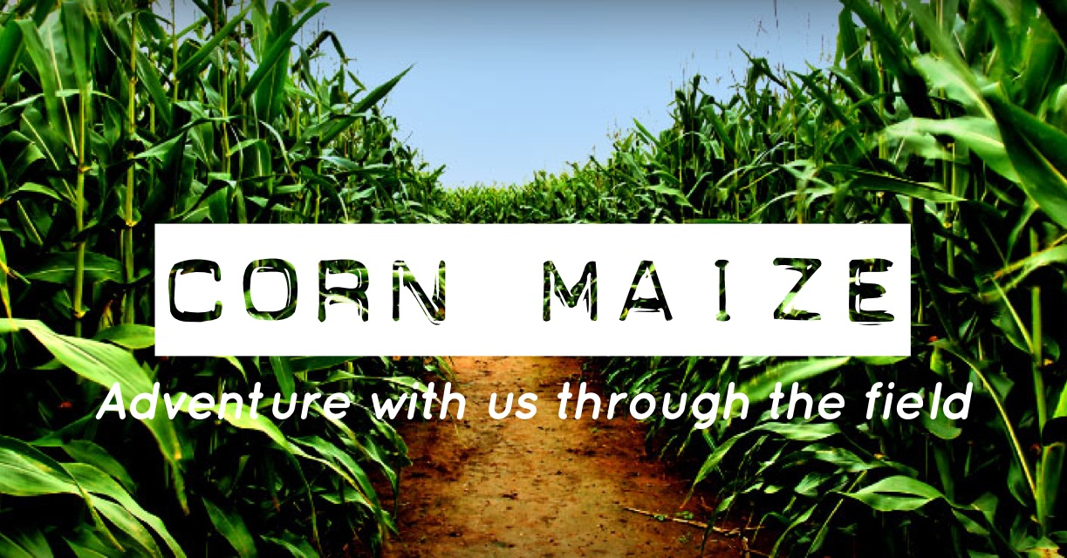
WHO: All youth 6th-12th grade
DATE: November 2nd, 2018
TIME: 5:45- 9:45pm
WHERE: Field of Adventure
MEETING LOCATION: FUMC
COST: $8.00 per person
Meet at the church. Bring money if you want snacks (concession stand located on the grounds) We will have a campfire/s’mores. Dress warm and bring a flashlight.

DUE: October 28th - Cut and return bottom portion to Lisa
Checks made out to FUMC with “Corn Maze” in the memo
_ _ _ _ _ _ _ _ _ _ _ _ _ _ _ _ _ _ _ _ _ _ _ _ _ _ _ _ _ _ _ _ _ _ _ _ _ _ _ _ _
Event: Corn Maize 2018
Name of Youth __________________________________________Grade_______________________
Emergency Contact for day of: _________________________ Emergency Contact #: _______________
Parent/Guardian Cell _________________________________ Youth Cell ________________________
Youth email ___________________________________P/G email ______________________________

Current “Participation and Medical Authorization Form” on file with Youth Dept? □ YES □ NO
Participating as an adult? □ YES □ NO (You must have clearances on file)
Are you willing to drive? □ YES □ NO I can transport _______ youth.

Participant Agreement:
I will conduct myself in a mature, respectful, and Christian manner as outlined in the Youth Covenant during this event. I will obey all rules and regulations set up by the youth department and those facilitating this event.
Youth Signature: ________________________________________________ Date: _____________________
Adult Permission:
As Parent/Guardian, I consent for___________________________________ to attend this church sponsored trip/event mentioned above. In the event of an accident or emergency involving my child in connection with this trip/event, I give my permission to the supervising adults to give or to seek whatever First Aid and/or Professional Medical Treatment they deem necessary. I further authorize the supervising adults to make medical decisions for my child until I am able to do so. I agree to hold harmless First United Methodist Church, its Pastors and members, agents, assigns, and all of the supervising adults of this trip/event from any and all liability associated with this trip/event including but not limited to any and all medical decisions on my behalf by the supervising adults and any and all injuries incurred by my child at this trip/event. This paragraph shall be construed broadly to allow supervising adults to make any and all emergency medical decisions on my behalf until I am able to do so.
Parent/Guardian Signature: ____________________________________________ Date: _________________
□ Check here if you would like to be considered for a scholarship for this event.

